Available online at [www.sciencedirect.com](http://www.sciencedirect.com/)



AASRI Procedia 3 (2012) 619 – 623

2012 AASRI Conference on Modeling, Identification and Control

Effect Analysis of a Passive Solar House in Tibet

Liu Wei*a*, Liu Dan*a*, Li Baiyi*b* , Zheng Min*c*

*a Faculty of geosciences and environmental engineering Southwest Jiaotong University, Chengdu 610031, P. R. China*

*b Faculty of Architecture, Southwest Jiaotong University, Chengdu 610031, P. R. China*

*c Faculty of tourist and urban planning, Chengdu University of Technology, Chengdu, 610000, P. R. China*

**Abstract**

This paper introduce a passive solar house in Tibet, which was divided into two parts by trombe wall, by measuring the temperature of two different parts, the result showed that the temperature in heat preserve room and bath room appeared different changes but had the similar trend with outside temperature.

© 2012 The Authors. Published by Elsevier B.V. Open access under [CC BY-NC-ND license.](http://creativecommons.org/licenses/by-nc-nd/3.0/)

© 2012 Published by Elsevier B.V. Selection and/or peer review [under responsi](http://creativecommons.org/licenses/by-nc-nd/3.0/)bility of American Applied Science Research Institute

Selection and/or peer review under responsibility of American Applied Science Research Institute

*Keywords:* Passive solar house, trombe wall, temperature;

# Introduction

With an average altitude over 4000m, Tibet has been called the “Roof of the World”. Rapid economic growth and booming tourism have Challenged the energy supply system of Tibet greatly, moreover, with the development of peoples living standard, the requirement of improve the indoor thermal environment would put greater pressure on it. On the other hand, solar energy resource in Tibet is the richest where receives an average annual radiation intensity of 7000MJ/m2 because of its small cloudy, rarified atmosphere, high transparency, low water and dust content. Therefore, how to utilize the solar energy resource to improve building indoor environment and living conditions in Tibet has attracted more and more attentions of researches. Many documents on the utilization of passive solar house were published [1-4]. Wang Discussed the distribution features of solar energy in Tibet [5, 6]. This paper will introduce and discuss a field test of a

2212-6716 © 2012 The Authors. Published by Elsevier B.V. Open access under [CC BY-NC-ND license.](http://creativecommons.org/licenses/by-nc-nd/3.0/) Selection and/or peer review under responsibility of American Applied Science Research Institute doi:10.1016/j.aasri.2012.11.098

passive solar house in Tibet region, which could provide guidance to the design and operation of passive solar house in this region.

# Introduction to testing solar house

The building located at nearly 5300 meters above the sea, the lowest outdoor temperature in the coldest month is below -40  , with more than 330 frost days and more 3.0m frost line, above 8-class winds. The people living here even cannot take a bath throughout the year, the water for eating are from ice, passive solar houses was designed for solving the problem of water for eating and taking bath for the residents, locating at the south of the buildings.

The height of solar house is 2.5 meters, considering local latitude and the solar altitude angles in winter, the day lighting glass was incline with angle of 45 , area of 11.8 m2, the bottom of incline plane was connected with a vertical glass of 1.85 m high, area of 7.42 m2,

Solar house can be divided into two areas by trombe wall: the bathroom and the heat preservation room. The incline glass was cross the two part of the solar house, the heat preservation room can get sunlight from the incline plane directly. Single-layer ordinary transparent glass with 5 mm thickness was used for day lighting, Light transmission ratio  of glass is 70%, The east, west, north wall of solar house was established on the wall of pool vertically with the same size, decorating heat storage material as much possible as it can, which can increase the thermal inertia of solar house, and the bath room can increase its temperature at the same time. The south of trombe wall was consisted with 200mm thick concrete brick; the west and east side wall was also used as heat collection and storage wall. The outside surface of south trombe wall was black, four holes for draught with the same size 400  250, two uptakes and two downtakes.

The water pool was built under the solar house; the principle of water pool is that it can not be buried too deeply. the north wall near the site of the mountain slope to make full use of the topography, extend the north slope frozen line level, so it can ensure that north wall of pool can not be frozen, south and east, west wall of the pool can heat themselves by heat absorption, heat transfer and heat conduction from bathroom, and establish the dynamic heat balance above zero.

Heat pipe vacuum tube solar energy water heater collector was applied to supply heat water firstly, electrical heating system was used as complementary energy with the power of electric heaters 2 kW, the light area of heat pipe vacuum tube was 1.2 m2. Effective volume of water tank was 150 liters, locating in the highest point of solar house, without insulation which can increase the direct heating area.

# 3 The measurement method

The tested parameters included indoor temperature (the bathroom and heat preservation room), outside temperature, solar radiation intensity.

Sensor arrangement: indoor temperature sensor was settled (the bathroom, heat preservation room) at the height of 1.5 m from ground; outside temperature sensor was settled at height of 1.5m from ground, under the shadow and without wind. The Solar radiation intensity measurement instrument was settled at 1.0 m from ground outside the window.

Measuring instrument: the precision of 0.1  thermometer mercury, the solar radiation meter Temperature and solar radiation intensity was recorded hourly.

# Result and analysis

* 1. *Mean solar radiation intensity*

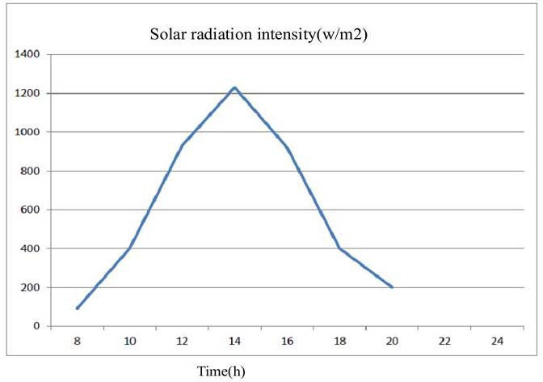

Fig.1 Hourly solar radiation intensity (mean value)

It can be seen from Figure.1, due to the insignificant cloudy influence on the mountain, thinner atmosphere with 410 mmHg atmospheric pressure, the daily solar radiation intensity was sine-wave curve obviously, the maximum valve reached to 1200W/m2 at 14:00, which was benefit to heat gain of solar house.

* 1. *Analysis of hourly temperature*

It could be seen from Figure 2 the daily highest temperature of preserve house and bathroom occurred in 14:00-16:00, the minimum temperature appeared at approximately 7:00. The highest temperature bathroom reached at about 30  , which indicate that the design of solar house can satisfy the bath requirements.

The preserve room temperature was smaller than that of the bathroom, and at the night heat loss of bathroom was larger than that of preserve room, which leading to the temperature of the former was below than that of latter. However, the trend of temperature of bathroom and preserve room was similar to outside trend with a delay.

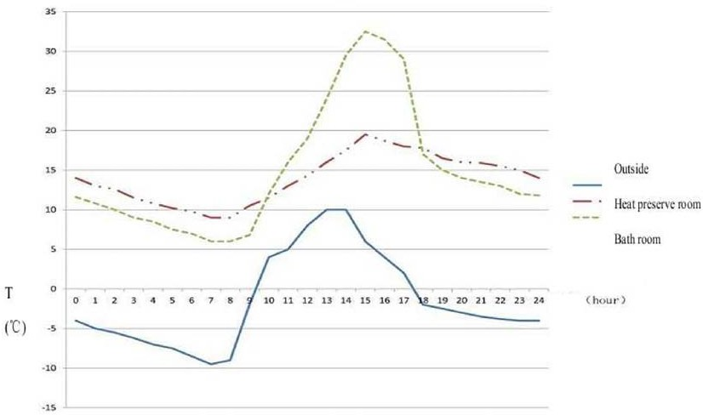

Fig.2 The temperature of outside, preserve room and bath room (mean value)

* 1. *Daily maximum and minimum temperature*





Fig.3 Daily maximum temperature

The testing date were from 20th Nov to 28th Nov, 2011 The highest temperature of the bathroom was significantly higher around 10  than that of the preserve house temperature, which could satisfied the use requirement of bathroom. The lowest temperature of preserve room was larger than that of bathroom with 3 

~4  , which indicated the fluctuation of preserve room was smaller than that of bathroom. In the test conditions, the daily mean temperature of these two different places ranged from 12.77  ~14.60  to 11.21 

~13.95  respectively, as shown in figure 3 and 4. The results indicate that the client’s requirement for bath room was satisfied.





Fig.4 Daily minimum temperature

# Conclusion

 The bath room and preserve room have the similar change of temperature with the outside temperature.

 In four to six hours for using the bath room, the temperature could increase up to 30  which can satisfy the demand of bath room.

# Reference

1. Tibet Statistical Yearbook-2008. Tibet Statistical Yearbook-2008. Lhasa: Tibet Autonomous Bureau of Statistics and Tibet General Team of Investigation under the NBS; 2008 [in Chinese]
2. Tsoutsos T, Frantzeskaki N, Gekas V. Environmental impacts from the solar energy technologies. Energy Policy 2005;33(3):289–96.
3. Wang Y-Q, Wang J-L. Tibet solar energy develop existing problem and several suggestions. Tibet’s Science & Technology 2007;166(2):26–8 [in Chinese].
4. Wei X-H, Yang P, Wang Y-J, Xie Z-K. Use of rural energy resources and eco-environmental degradation in Tibet. Journal of Environmental Sciences 2004;16(6):1046–50
5. Wang Y-Q, Basang L, Yang Y-J. Thinking over adjustment of energy structure in Tibet. Central South Forestry Inventory and Planning 2007;126(1):60–3 [in Chinese].
6. Cai G-T, Zhang L. Research on Tibet rural energy consumption and its envir-onmental impact. Resource Development & Market 2006;22(3):238–41 [in Chinese]